**3D Simulation Android Game for Japanese Learning at Pamulang University using Unity and MDLC**

Andri Firman Saputra 1

Universitas Pamulang, Faculty of Computer Science, Informatics Engineering 1

[andrifirmansaputra1@gmail.com](mailto:andrifirmansaputra1@gmail.com) 1

|  |  |
| --- | --- |
| **Keywords​** | **Abstract** |
| Educational Android Games, Japanese Language, 3D Simulation, Unity Engine, Multimedia Development Life Cycle (MDLC) | Japanese language has become one of the foreign languages increasingly favored by students and university students in Indonesia. Despite its popularity, some find learning Japanese language quite challenging due to its complex script and grammar, which differs significantly from Indonesian. With the rapid advancement of technology, educational media, particularly educational games, have seen significant progress. This research aims to implement a 3D simulation game based on Android as a medium for learning Japanese language for students at Universitas Pamulang. The game is designed using Unity Engine and employs the Multimedia Development Life Cycle (MDLC) method in its development. Through this game, students can learn vocabulary, grammar, reading, and writing in Japanese language in a more interactive and engaging way. Quantitative data collection is conducted through questionnaires to measure the effectiveness of the game in enhancing Japanese language comprehension. The testing results indicate that the game received very good ratings from students, with a satisfaction rate of 85%. The conclusion of this research is that the Japanese language learning game “JepangCita: Game Simulasi 3D” can facilitate students at Universitas Pamulang in learning Japanese language through an interactive approach and increase their motivation to remain consistent in their studies. |

*Corresponding Author* : Andri Firman Saputra

E-mail: [andrifirmansaputra1@gmail.com](mailto:andrifirmansaputra1@gmail.com)

**[https://jurnal.syntax-idea.co.id/public/site/images/idea/88x31.png](https://creativecommons.org/licenses/by-sa/4.0/)**

**INTRODUCTION**

Japanese language is now one of the foreign languages ​​that is currently popular among students and students in Indonesia. Now, Japanese has been implemented as one of the components of the foreign language curriculum in a number of schools in Indonesia. In addition, several universities in Indonesia offer Japanese literature study programs that are increasingly popular among students. Although in demand by many people, some feel that learning Japanese is quite difficult because of its complicated letters and different grammar from Indonesian.

Along with the rapid development of technology, game-based learning media has progressed, and one of them is educational games. The creation of educational game applications has a main purpose, namely education. Educational games are also considered as alternative learning media that have been widely applied in a number of subject areas, including mathematics, Indonesian, English, and so on. Thus, this educational game emphasizes the concept of learning through games in the educational process (Gamma Ramadhan & Surahman, 2023).

Designing educational games as a means of learning Japanese through the Android platform aims to support Pamulang University students who are interested in Japanese. An interesting learning approach will be applied in this educational game application, so that it can be accessed by various groups of students. In order to address these challenges, innovative approaches that integrate technology, modern learning models, and game elements can be considered as alternatives in overcoming barriers to Japanese language learning. This research was chosen with the aim of presenting alternative learning through game creation and also functioning as fun entertainment using technology and information.

**RESEARCH METHODS**

In the implementation of the 3D Android simulation game in Japanese language learning for Pamulang University students with the Unity Engine using the Multimedia Development Life Cycle (MDLC) method, the author applies the following research methods:

1. Data Collection Method

To obtain accurate information, the author will use a quantitative research method that uses data in the form of numbers to answer the research hypothesis (Waruwu, 2023).

This method was chosen because it allows for objective and measurable data collection and is more efficient in terms of time and resources, especially when conducting questionnaires that can be accessed online. The data collection methods used include:

1. Questionnaire Method

The questionnaire was distributed online through social media to 22 Pamulang University students to collect data on their interests, motivations, and experiences in learning Japanese using educational games.

1. Literature Study Method

Secondary data collection from books, journals, and other relevant sources to support the analysis and development of educational games. The location of the literature study was conducted at the Pamulang University Library, located at Jl. Raya Puspitek, Buaran, Pamulang District, South Tangerang City, Banten 15310. The book references used include: “*Minna no Nihongo 2nd Edition Shokyu 1*” (Etsuko & Sachiko, 2012), “*Minna no Nihongo Shokyuu 1 Second Edition - Indonesian Edition*” (Etsuko & Sachiko, 2013) dan “*Kiat Sukses Mudah & Praktis Mencapai N5 Edisi Baru Metode Gakushudo*” (Shiang, 2018).

1. System Design Method

In the process of implementing the game “JepangCita: Game Simulasi 3D”, the author applies the Multimedia Development Life Cycle (MDLC) Method, MDLC is a method for designing and developing media applications that combine various types of media, such as images, sound, video, animation, and other multimedia elements (Tjahyadi & Antonio, 2022). In this study, the MDLC method was used which involved six stages of research, including concept, design, material collection, manufacturing, testing, and distribution. The stages of research carried out based on the MDLC process consist of the following:

1. Concept

At this concept stage, the purpose of the game and student identification are explained.

The purpose of the game created is to introduce Japanese, so that students can have more knowledge about Japanese and this game can be played on Android. Furthermore, the identification of game students in this study is students with an age range of 13 years and above.

The following is a table containing an explanation of the game that will be created:

Table 1. Game Description Table

|  |  |  |
| --- | --- | --- |
| **No.** | **Caption** | **Descriptive** |
| 1 | Game Title | JepangCita: Game Simulasi 3D |
| 2 | Target Audience | Students aged 13 years and above |
| 3 | Genre | 3D Simulation |
| 4 | Audio | Background Music (BGM) and Sound Effects (SFX) |
| 5 | Interactive | Using a laptop to read material, using a mattress to sleep, using the exit to go to the course location, following the class schedule, and working on missions |

Source table data reference: JepangCita Game Design Document

Based on Table 1 above, the game “JepangCita” is a 3D simulation game aimed at students aged 13 years and above. The game integrates both background music (BGM) and sound effects (SFX) to enhance the user experience. The interactive elements of the game include using a laptop for reading materials, a mattress for resting, and an exit feature for navigating to different course locations. Students will also follow a class schedule and complete various missions, which align with the educational objectives of introducing Japanese language and culture. The detailed descriptions provided in the table offer a comprehensive overview of the game's features and target audience, laying the foundation for its development and implementation.

1. Design

At this design stage there is an explanation for the storyboard and navigation structure in the game. The storyboard contains the Graphical User Interface (GUI) display, while the navigation structure explains the buttons used in the game. The following is a complete description of the storyboard available for the game, including an explanation of each GUI display and the function of each button in the navigation structure:

* 1. Storyboard Main Menu

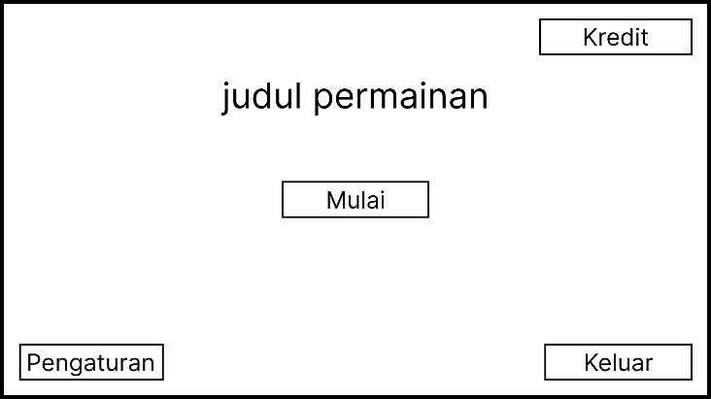

**Figure 1. Storyboard Main Menu**

On the main menu storyboard, students can create several navigation structures, such as a start button to start the game, a settings button to set up the game, a credit button to display developer data and assets used in the game, and an exit button to exit the game.

* 1. Storyboard Character Selection

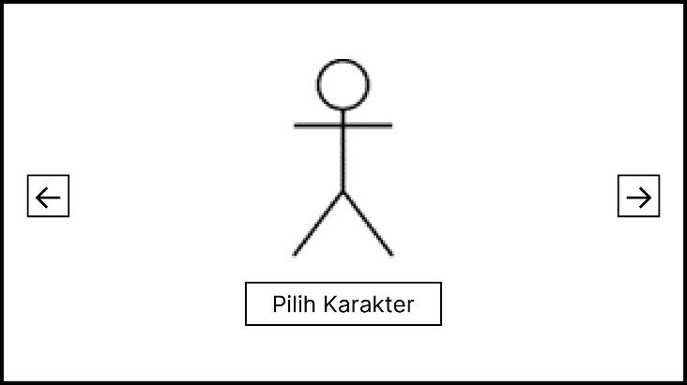

**Figure 2. Storyboard Character Selection**

In the character selection storyboard, students can navigate through several structures, such as the character select button to select the character they want to use, the right/left arrow buttons to change the characters displayed on the screen, and the continue button to continue the game to the next gameplay storyboard. This navigation structure is designed to provide an intuitive flow and make it easier for users to select and continue the game.

* 1. Storyboard Gameplay

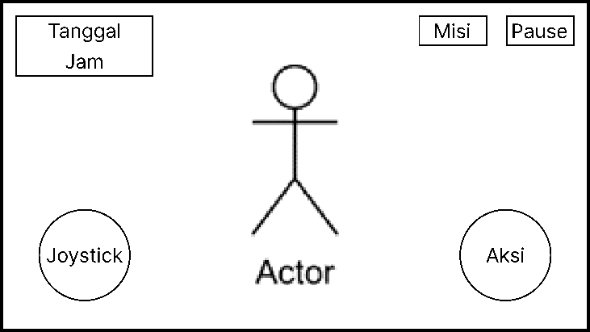

**Figure 3. Storyboard Gameplay**

In the gameplay storyboard, students can do several navigation structure activities, such as the joystick button to move the character, the action button to perform actions according to the object (the action button will appear if the character is close to the action object), the mission button to display the mission that must be completed, the pause button to stop the game and display buttons, such as the continue game button to continue the game, the settings button to make settings and the main menu button to return to the main menu.

1. Material Collecting

The data collection process with literature studies used as references in the research process for Japanese language learning games. Literature studies in the form of books, related journals and relevant websites. Furthermore, for game assets such as 3-dimensional objects, characters, audio and others are obtained through a website called the Unity Asset Store. The Unity Asset Store is a collection of materials for making games while for making 3-dimensional character animations through a website called Adobe Mixamo.

1. Assembly

Based on the design stage that has been made, after the material collecting stage, it is continued to the assembly stage. At the game assembly stage, it starts by creating a main menu with 2D assets that have been created previously using Figma. After that, create game mechanisms such as mission mechanisms, display materials, move characters, calculate exam scores, set class schedules, and others. This game was created using Unity, UI/UX design using Figma and Adobe Photoshop and 3D character animation using Mixamo.

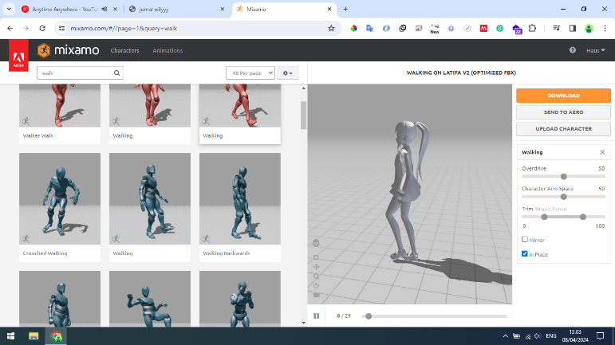

**Figure 4. 3D Animation Creation Process**

In figure 4 is the process of creating 3D animation which begins by uploading 3D characters obtained from the Unity Asset Store. This process is carried out to create the required animations such as idle, walk, sit, and others.

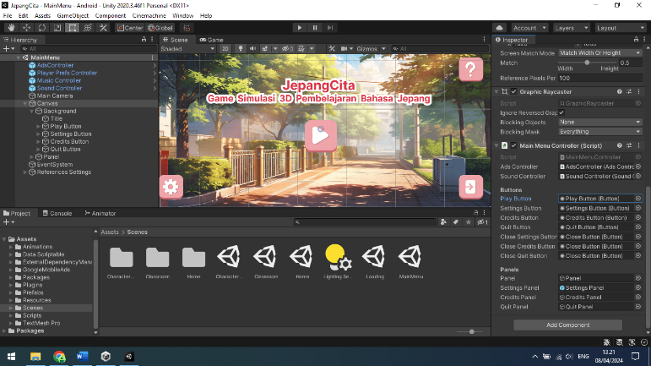

**Figure 5. Main Menu Creation Process**

Figure 5 shows the game creation process that starts from creating the main menu scene. In this process, the steps taken include installing the background, creating buttons, and creating mechanisms using the C# script programming language.

1. Testing

At this stage, a trial is conducted to determine whether the application is running well or not. If there are no errors in the application, then testing is carried out by students.

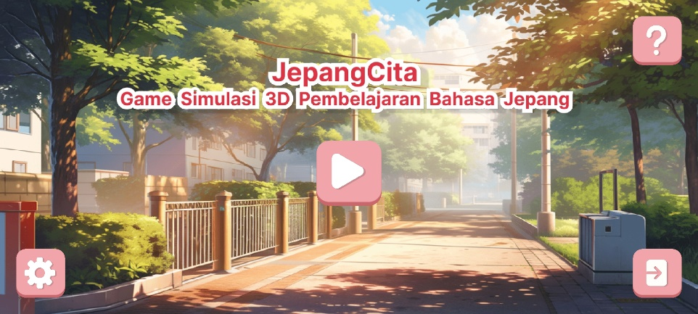

**Figure 6. Scene Main Menu**

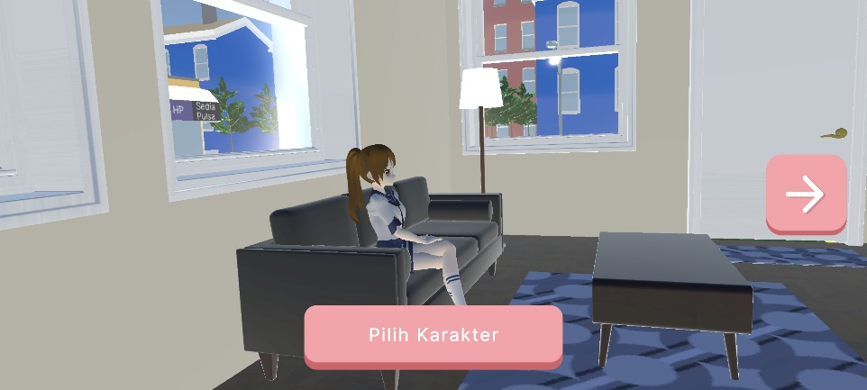

**Figure 7. Scene Character Selection**

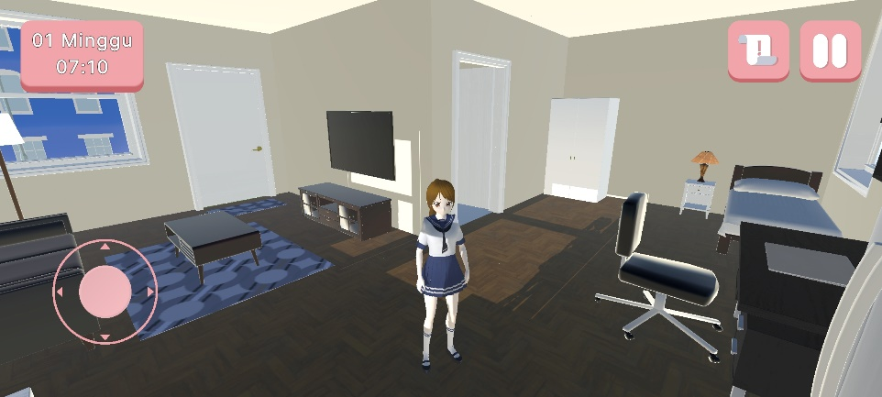

**Figure 8. Scene Gameplay**

1. Distribution

Based on the game application that has been created, it is continued to the distribution stage. Distribution can be done after the game application is declared suitable for use. This application is distributed or published through the Google Play Store. Here is the link to download the game:

<https://play.google.com/store/apps/details?id=com.HakoLab.JepangCita>

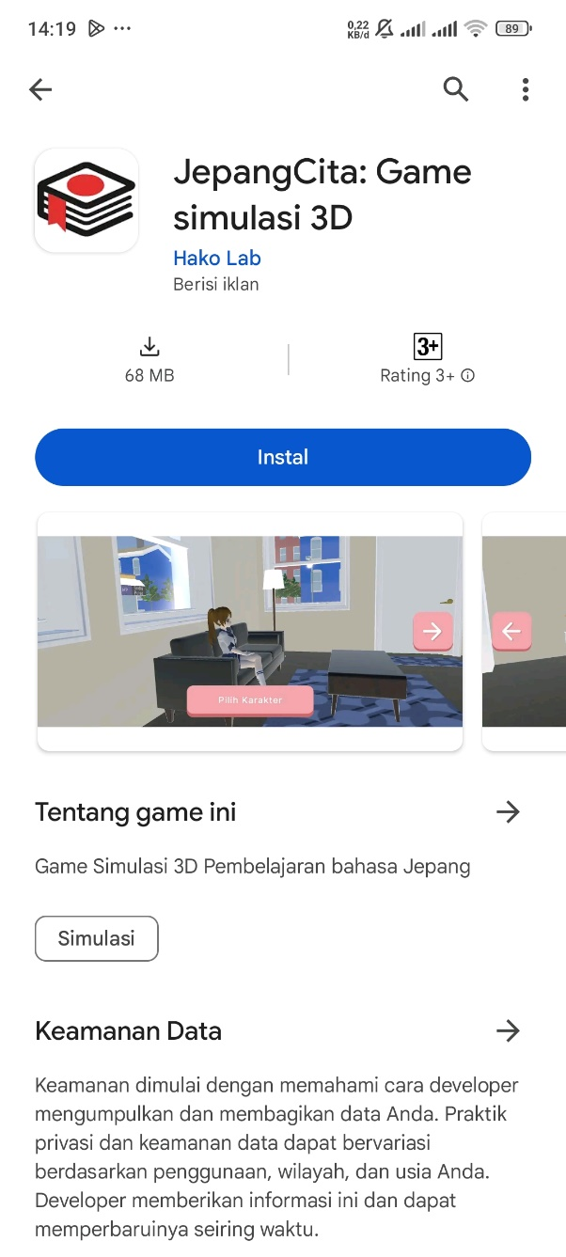

**Figure 9. The Application is Available on Google Play Store**

**RESULTS AND DISCUSSION**

The game “JepangCita” was successfully developed and received positive feedback from the students. The game focuses on teaching basic Japanese concepts such as Hiragana, Katakana, and simple grammar structures. The results of the user acceptance testing, which involved 22 students, indicated an overall satisfaction rate of 85%, with most students agreeing that the game improved their motivation and made learning more enjoyable compared to traditional methods.

The MDLC method proved effective in structuring the game development process, ensuring that all aspects of the game were aligned with the educational objectives. The game's interactive elements, such as character selection, immersive gameplay, and real-time feedback, contributed to higher engagement levels among students. Furthermore, the game facilitated independent learning, allowing students to practice Japanese outside the classroom.

In comparison with similar studies, the integration of 3D simulations in language learning has shown consistent results in enhancing students' engagement. The study supports the notion that gamified learning environments can address the shortcomings of traditional language teaching methods, such as monotony and lack of student interaction.

**CONCLUSION**

From the results of the implementation of the Android 3D Simulation game in Japanese language learning “JepangCita: 3D Simulation Game” with the Multimedia Development Life Cycle (MDLC) method, the following conclusions were obtained:

1. The JepangCita game has succeeded in making it easier for Pamulang University students to learn Japanese. The results of the questionnaire showed that the average assessment was in the good to very good category in terms of ease of learning science, grammar, and improving Japanese reading and writing skills.
2. This game also succeeded in increasing the motivation of Pamulang University students to remain consistent in learning Japanese. The results of the questionnaire showed that most respondents felt more motivated after playing this game.

**REFERENCES**

Etsuko, H., & Sachiko, M. (2012). *Minna no Nihongo 2nd Edition Shokyu 1* (2nd ed., Vol. 1). 3A Network.

Etsuko, H., & Sachiko, M. (2013). *Minna no Nihongo Shokyuu 1 Second Edition - Indonesian Edition* (2nd ed., Vol. 1). 3A Network.

Gamma Ramadhan, R., & Surahman, A. (2023). Media Pembelajaran Aksara Jepang Berbasis Android untuk Siswa SMA Kelas X. *JURNAL INFORMATIKA DAN REKAYASA PERANGKAT LUNAK (JATIKA)*, *4*, 246–252. https://doi.org/10.33365/jatika.v4i2.2602

Shiang, T. T. (2018). *Kiat Sukses Mudah & Praktis Mencapai N5 Edisi Baru Metode Gakushudo* (R. Trisno, Ed.). Gakushudo.

Tjahyadi, S., & Antonio, W. (2022). Perancangan dan Implementasi Media Pembelajaran di SMA Kartini Batam Menggunakan Metode MDLC. *Prosiding National Conference for Community Service Project (NaCosPro)*, *4*, 1107–1112. http://journal.uib.ac.id/index.php/nacospro

Waruwu, M. (2023). Pendekatan Penelitian Pendidikan: Metode Penelitian Kualitatif, Metode Penelitian Kuantitatif dan Metode Penelitian Kombinasi (Mixed Method). *Jurnal Pendidikan Tambusai*, *7*, 2896–2910.